**CHAPTER 1**

**INTRODUCTION**

Now a days, the composite engineers are focusing on the development of new stronger tougher, lightweight structural materials supporting latest technologies and design concepts for the complex shaped structures like aircraft, automotive structures and large wind turbine blade structures. The development of composite materials improves their performance based on the reinforcement of two or more fibers in a single polymeric matrix, which leads to the advanced material system called hybrid composites with a great diversity of material properties. This is a major challenge that can only be met through an understanding of the relationships between materials architecture and mechanical response. The positive or negative hybrid effect of selected mechanical property from the rule of mixture behavior of carbon/carbon/epoxy and glass/carbon composites were studied. None of the mechanical properties, excluding the fracture energies show signs of a positive hybrid effect. Manders and Bader (1981) reported hybrid effect and failure strain enhancement of up to 50% for the glass fiber/carbon fiber/epoxy composite. The failure strain of the carbon phase increased as the relative proportion of carbon fiber was decreases and as the carbon fibers were more finely dispersed. Yerramalli and Waas (2003) have considered carbon/ glass hybrid composite with an overall fiber volume fraction of 30%. Splitting and kinking failures were noted while loading the hybrid laminates under static and dynamic loading rates. Zhang *et al.* (2012) studied the mechanical behavior of hybrid composites made of carbon/glass reinforcements and the processing method used is ‘wet lay-up’ which is not a best practice for obtaining high quality laminates. An addition of hard reinforcements such as silicon carbide, alumina and titanium carbide improves hardness, strength and wear resistance of the composites. The introduction of a glass fiber into a polymer matrix produces a composite material that results in an attractive combination of physical and mechanical properties which cannot be obtained with monolithic alloys (Schwartz, 1984). Among the various useful polymer matrices, vinyl ester is typically characterized by properties such as fluidity, corrosion resistance and high strength-weight ratio (Suresha *et al.*, 2007) [1]. The advantages of Fiber-reinforced PMCs over traditional materials include greater mechanical strength, lighter weight, better dimensional stability, higher dielectric strength and corrosion resistance and flexibility to improve the designs (Folkes, 1992). The effectiveness of reinforcement essentially depends on the adhesion between matrix and fiber, so this is a key factor in determining the final properties of the composite material, particularly its mechanical properties (Yosoyima *et al.*, 1984; Yosoyima *et al.*, 1990; and Pukzky *et al.*, 1995). In the present work, an attempt has been made to study the influence of glass fiber and carbon fiber reinforced epoxy polymer matrix on the mechanical properties.

**CHAPTER 2**

**LITERATURE REVIEW**

**[1]Improvement on cost-performance ratio of fiberglass/carbon fiber hybrid composite**

Nathawat POOPAKDEE, Warut THAMMAWICHAI

Fiberglass composite (FG) is widely used as a metal substitute in general applications due to its corrosion and chemical resistance, relatively high strength, and low cost. Still, the FG is deficient in performance and relatively heavy for airframes. Carbon fiber composite (CF) is utilized instead as it has greater performance and lower weight. However, the CF is brittle and expensive. Thus, in this work, we combine FG and CF into two types of hybrid composites to achieve a cost-effective solution with greater or comparable mechanical properties to those of CF. The first one uses FG as core and CF as skins (SWFG). The second one uses CF as core and FG as skins (SWCF).Their mechanical properties and cost-performance ratios (CPR) are compared. The results show that the mechanical properties of the SWFG composite, especially the modulus of elasticity, are considerably improved over the FG and nearly match those of the CF. Also, the SWFG has better CPR regarding tensile properties and flexural modulus than the SWCF and the CF. The SWFG shows promising potential as an alternative to the CF due to its comparable performance and almost 40% lower cost than the CF

**[2]Influence of angle ply orientation on tensile properties of Carbon/Glass hybrid composite**

MN Guru Raja, AN HariRao

Hybrid composites are considered materials of great potential for engineering applications. One advantage of hybrid composite materials for the designer is that the properties of a composite can be controlled to a considerable extent by the choice of fibers and matrix and by adjusting the orientation of the fiber. The scope for this tailoring of the properties of the material is much greater, however, when different kinds of fiber orientations are incorporated in the same resin matrix. For the study of potential of these materials, in this work specimens were prepared with different angle ply orientation of carbon/glass hybrid with epoxy resin as an adhesive. Three orientations viz 0/90, 45/45 and 30/60 were considered for studies. Mechanical properties such as tensile strength, tensile modulus, & peak load of the hybrid composites were determined as per ASTM standards. Vacuum bagging technique was adopted for the fabrication of hybrid specimens. It was observed that angle ply orientation at 0/90 showed significant increase in tensile properties as

Compared to other orientation. Scanning electron micrographs of fractured surfaces were used for a qualitative evaluation of interfacial properties of woven carbon-glass hybrid composites. These results indicated that carbon-glass hybrid composites offered the merits of synthetic fibers.

**[3]Effect of stacking sequence on the flexural properties of carbon and glass fibre-reinforced hybrid composites**

Chensong Dong, Ian J Davies

Study on the flexural properties of carbon and glass fibre-reinforced epoxy hybrid composites is presented in this paper. For the purpose of understanding the effect of stacking sequence on the flexural properties, test specimens of both glass/carbon and sandwich stacking sequences were studied both experimentally and by simulation. The experimental flexural properties were obtained by three-point bend test in accordance with ASTM D7264/D7264M-15. Simulation was achieved with the aid of finite element analysis (FEA) and classical lamination theory (CLT). From the experimental and simulation results, it is concluded that for the hybrid composites with glass/carbon stacking sequences, when glass/epoxy laminas are placed on the compressive face, positive hybrid effects are present. When glass/epoxy laminas are placed on the tensile face, the hybrid effect is dominantly negative

**[4]Compression properties of interlayer and interlayer carbon/glass hybrid composites**

Qingtao Wang, Weili Wu, Wei Li

The compression properties and mechanisms of interlayer and intralayer Carbon/Glass (C/G) hybrid composites were investigated in this work. As revealed from the experimental results, the compression modulus increases linearly with the increase of carbon fiber content, following the rule of mixtures (ROM). The C/G hybrid ratio is regarded as the decisive factor for the compression modulus of hybrid composites. The positive mixing effect exists on compression strength for interlayer and intralayer hybrid composites, whereas the experimental values are above the theoretical calculation values. The compressive strength of interlayer hybrid composites taking on various hybrid structures differs largely at the same mixed ratio, at which the compressive strength of glass fiber sandwiching carbon fiber is higher than that of carbon fiber sandwiching glass fiber. Through comparing interlayer and intralayer hybrid composites, the impact exerted by layer structures on the compressive strength of interlayer hybrid composites is higher than that of intralayer hybrid composites, which leads to more designable characteristics for interlayer hybrid composites.

**[5]Hybrid effects on tensile properties of carbon/glass angle ply composites**

MN GuruRaja, AN HariRao

Hybrid composites are considered materials of great potential for engineering applications. One advantage of hybrid composite materials for the designer is that the properties of a composite can be controlled to a considerable extent by the choice of fibers and matrix and by adjusting the orientation of the fiber. The scope for this tailoring of the properties of the material is much greater, however, when different kinds of fiber orientations are incorporated in the same resin matrix. For the study of potential of these materials, in this work specimens were prepared with different angle ply orientation of carbon/glass hybrid with epoxy resin as an adhesive. Three orientations viz 0/90, 45/45 and 30/60 were considered for studies. Mechanical properties such as tensile strength, tensile modulus, & peak load of the hybrid composites were determined as per ASTM standards.

**[6]Influence of Carbon & Glass Fiber Reinforcements on Flexural Strength of Epoxy Matrix Polymer Hybrid Composites**

TD Jagannatha, G Harish

Hybrid composite materials are more attracted by the engineers because of their properties like stiffness and high specific strength which leads to the potential application in the area of aerospace, marine and automobile sectors. In the present investigation, the flexural strength and flexural modulus of carbon and glass fibers reinforced epoxy hybrid composites were studied. The vacuum bagging technique was adopted for the fabrication of polymer hybrid composite materials. The hardness, flexural strength and flexural modulus of the hybrid composites were determined as per ASTM standards. The hardness, flexural strength and flexural modulus were improved as the fiber reinforcement contents increased in the epoxy matrix material

**[7]Effect of the stacking sequence on the impact response of carbon-glass/epoxy hybrid composites**

Hafiz Tauqeer Ali, Roya Akrami, Sakineh Fotouhi, Farzad Pashmforoush, Cristiano Fragassa, Mohammad Fotouhi

This paper investigates low-velocity impact response of Quasi Isotropic (QI) hybrid carbon/glass fiber reinforced polymer composites with alternate stacking sequences. Cross-ply woven carbon and glass fibers were used as reinforcing materials to fabricate Sand wiched and interlayer hybrid composites. For comparison, the laminates containing only-carbon and only-glass fibers were also studied. Drop weight test was used to impact the samples. The images captured by a normal camera demonstrated that localized damages (delamination) existed within plies. The hybrid laminates had smaller load drops, smaller maximum deflection, and higher maximum load compared to the single fiber laminates. In addition, carbon outside interlayer hybrid laminate showed the highest maximum load and energy absorption, showing the significant dependence of the impact performance on hybridization and stacking sequence. It was concluded that a hybrid composite would help improve impact performance of laminated composites compared to non-hybrid composites if they are properly designed.

**[8]Comparison of tensile and compressive properties of carbon/glass interlayer and intralayer hybrid composites**

Weill Wu, Qingdao Wang, Wei Li

Tensile and compressive properties of interlayer and intralayer hybrid composites were investigated in this paper. The tensile modulus and compression modulus of interlayer and interlayer hybrid composites are the same under the same mixed ratio, the tensile strength is much superior to the compression strength, and while the tensile modulus and strength increase along with the carbon fiber content, the compression values change slightly. The influence of stacking structures on the tensile and compressive strengths is opposite to the ratio of T/C (tensile/compression) strength for interlayer hybrid composites, and while the tensile and compression strengths with glass fiber sandwiching carbon fiber can reach the maximum value, the ratio of T/C strength is minimum. For structures with carbon fiber sandwiching glass fiber, or with asymmetric structures, the tensile and compressive strengths are at a low value. For intralayer hybrid structures, while the carbon/glass (C/G) dispersion degree is high, the tensile and compression strengths are low.

**[9] GF/CF hybrid laminates made through intra-tow hybridization for automobile applications**

Hasan Ikbal, Qingtao Wang, Ahmed Azzam, Wei Li

Fibers and Polymers 17 (9), 1505-1521, 2016

Among the drawbacks that the composites entirely reinforced with carbon fibers have, low strain-to-failure and catastrophic failure behaviour are the most undesirable ones. Nonetheless, in many industries for example in automobile industries, the necessity of Light-weight structures with a balanced cost is unquestionable. Hybridization of glass fibers with carbon fibers could be an effective way to improve the strain-to-failure of composites entirely reinforced carbon fibers and therefore, a balance between the stiffness and toughness could be improved without excessive cost. In this paper, for automobile applications it is proposed to selectively incorporate the glass and carbon fibers through intra-layer hybridization technique. It is also proposed to mix the fibers as intimately as possible. This paper investigates the influences of hybrid ratio and laminate geometry on tensile mechanical properties both computationally and experimentally- and they have been found to have significant influences on tensile properties and hence should be treated as most crucial parameters. The brittle and catastrophic failure of plain carbon composite was avoided through intra-tow hybridization with higher dispersion. Damage mechanism has been explained and SEM observations were carried out for morphology analysis. Vacuum assisted resin infusion process is also recommended to attain high quality of impregnation.

**[10] Glass/carbon fibre hybrid composite laminates for structural applications in automotive vehicles**

J Zhang, K Chaisombat, S He, CH Wang

Sustainable Automotive Technologies 2012, 69-74, 2012

Light-weight structure is one of the keys to improve the fuel efficiency and reduce the environmental burden of transport vehicles (automotive and rail). While fibreglass composites have been increasingly used to replace steel in automotive industry, the adoption rate for carbon fibre composites which are much lighter, stronger and stiffer than glass fibre composites, remains low. The main reason is the high cost of carbon fibres. To further reduce vehicle weight without excessive cost increase, one technique is to incorporate carbon fibre reinforcement into glass fibre composites and innovative design by selectively reinforcing along the main load path. Glass/carbon woven fabrics with epoxy resin matrix were utilised for preparing hybrid composite laminates. The in-plane mechanical properties such as tensile and three-point-bending flexural properties were investigated for laminates with different carbon fibre volume and lay-up scheme. It is shown that hybrid composite laminates with 50 % carbon fibre reinforcement provide the best flexural properties when the carbon layers are at the exterior, while the alternating carbon/glass lay-up provides the highest compressive strength.

**[11] Hybrid composite laminates reinforced with glass/carbon woven fabrics for lightweight load bearing structures**

Jin Zhang, Khunlavit Chaisombat, Shuai He, Chun H Wang

Materials & Design (1980-2015) 36, 75-80, 2012

Light-weight structure utilising novel design and advanced materials is one of the keys to improving the fuel efficiency and reducing the environmental burden of automotive vehicles. To ensure the low cost of applying fibre-reinforced materials in automotive vehicles, it is proposed to selectively incorporate carbon fibres to enhance glass fibre composites along main loading path. This paper investigates the influences of stacking sequence of on the strength of hybrid composites comprising materials with differing stiffness and strength. Hybrid composite laminates were manufactured using varying ratio of glass woven fabric and carbon woven fabric in an epoxy matrix. Static tests including tension, compression and three-point-bending were carried out to composite coupons containing various ratios of carbon fibres to glass fibres. The results show that hybrid composite laminates with 50% carbon fibre reinforcement provide the best flexural properties when the carbon layers are at the exterior, while the alternating carbon/glass lay-up provides the highest compressive strength. The tensile strength is insensitive to the stacking sequence. Analytical solutions are also developed and are shown to provide good correlation with the experimental data, which allow the optimisation of stacking sequence of hybrid composites to achieve the maximum strength.

**[12] Impact response and damage tolerance characteristics of glass–carbon/epoxy hybrid composite plates**

NK Naik, R Ramasimha, HEMENDRA Arya, SV Prabhu, N ShamaRao

Composites Part B: Engineering 32 (7), 565-574, 2001

Impact behaviour and post impact compressive characteristics of glass–carbon/epoxy hybrid composites with alternate stacking sequences have been investigated. Plain weave E-glass and twill weave T-300 carbon have been used as reinforcing materials. For comparison, laminates containing only-carbon and only-glass reinforcements have also been studied. Experimental studies have been carried out on instrumented drop weight impact test apparatus. Post impact compressive strength has been obtained using NASA 1142 test fixture. It is observed that hybrid composites are less notch sensitive compared to only-carbon or only-glass composites. Further, carbon-outside/glass-inside clustered hybrid configuration gives lower notch sensitivity compared to the other hybrid configurations.

**[13]Review on hybrid composite materials and its applications**

N Subramani, J Ganesh Murali, P Suresh, VV Arun Sankar

International Research Journal of Engineering and Technology 4 (2), 1921, 2017

The review article of this paper represents the reduced availability of natural resources, the increasing costs of production, and the apparent limit to our ability to fabricate high strength-to-weight metallic components necessitated the development of new materials to meet the demands of aerospace technology. These materials are called advanced composite materials and will be used to replace some of the metals currently used in aircraft construction. Advanced composites are materials consisting of a combination of high-strength stiff fibers embedded in a common matrix (binder) material, generally laminated with plies arranged in various directions to give the structure strength and stiffness. The much stiffer fibers of boron, graphite, and Kevlar have given composite materials structural properties superior in strength to the metal alloys that they have replaced.

**OBJECTIVE**

* Developing the 2-ply Intra Woven using Carbon/Glass fiber for different turns as per ASTM standard
* Developing the uni-directional fabric using hand stitch method.
* Developing the composite by aid of hand layup.
* Performing the tensile flexural & compression test as per ASTM standard

**CHAPTER 3**

**STUDY OF COMPOSITE MATERIALS**

**3.1 COMPOSITE MATERIALS**

A composite material is a material which is produced from two or more constituent materials. These constituent materials have notably dissimilar chemical or physical properties and are merged to create a material with properties unlike the individual elements. When they are combined they create a material which is specialised to do a certain job, for instance to become stronger, lighter or resistant to electricity. They can also improve strength and stiffness.

Composite materials are generally used for **buildings, bridges, and structures** such as boat hulls, swimming pool panels, racing car bodies, shower stalls, bathtubs, storage tanks, imitation granite and cultured marble sinks and countertops. They are also being increasingly used in general automotive applications.

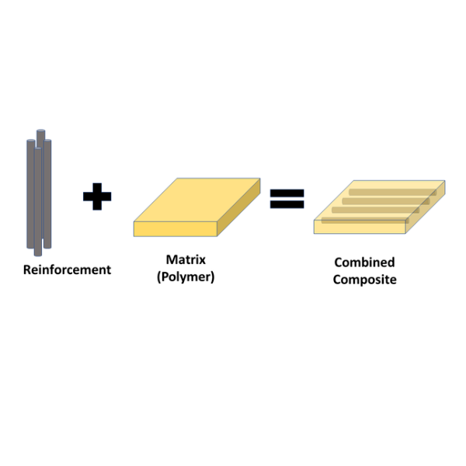

**Fig 3.1** Composite of material

**3.2 MATRIX**

The matrix material is the homogeneous and monolithic material in which a reinforcement system of a composite is embedded and is completely continuous.

The main purpose of the Matrix is to

* To bind the reinforcements together by virtue of its cohesive and adhesive characteristics.
* To transfer the load to and between reinforcements, the matrix allows the strength of the reinforcements to be used to their full potential by providing effective load transfer from external forces to the reinforcement.
* The matrix provides a vital inelastic response so that stress concentrations are reduced dramatically, and internal stresses are redistributed from broken reinforcements.
* To protect the reinforcements from environments and handling.
* The matrix also provides a solid form to the composite, which aids handling during manufacture and is typically required in a finished part.
* As a continuous phase, the matrix, therefore, controls the transverse properties, interlaminar strength, and elevated-temperature strength of the composite.

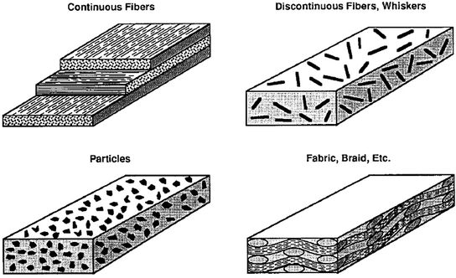

**Fig3.2** Representation of matrix

**3.2.1 CLASSIFICATION OF MATRIX**

**Metal Matrix Composites (MMC)**

Though generating a wide interest in research, are not as widely in use as plastic. High strength, fracture toughness and stiffness are offered by metal matrices when Compared to their polymer counterparts. Withstand elevated temperature in corrosive environment than polymer composites. Most metals and alloys – used as matrices. Hence, require reinforcement materials – stable over a range of temperatures and non-reactive too. Guiding aspect for the choice depends on matrix material. Light metals (low strength) form the matrix while the reinforcements have high moduli. If metal matrix has high strength, they require even higher modulus reinforcements. Hence, light metals (Al, Ti, and Mg) are the popular matrix metals with their low density. E.g. carbide in a metal matrix. The melting point, physical and mechanical properties of the composite at various Temperatures determine the service temperature of composites. Most metals, ceramics and compounds can be used with matrices of low melting point alloys. As the melting points of matrix materials become high, the choice of reinforcements becomes small.

**Polymer Matrix Composites (PMC)**

**Thermosets**

1. Epoxy resins

* Widely used in filament-wound composites and electrical circuit boards.
* Reasonably stable to chemical attacks and are excellent adherents having slow shrinkage during curing and no emission of volatile gases.
* These advantages make epoxies expensive.
* Cannot be used above 140Oc (limiting their applications).

1. Polyester resins

* Easily accessible, cheap and used widely.
* stored at room temperature for long periods and the mere addition of a catalyst can cure the matrix material within a short time.**SATADRU**
* Cured polyester is usually rigid or flexible and transparent.
* Used in automobile and structural applications.
* Withstand the variations of environment and stable against chemicals and can be used up to about 75Oc or higher.
* Compatibility with few glass fibers and can be used with variety of reinforced plastic.

1. Aromatic Polyamides

* Most sought after as the matrices of advanced fiber composites for structural applications demanding long duration exposure for continuous service at around 200-250Oc.

**Ceramic Matrix Composites (CMC)**

Ceramics- solid materials which exhibit strong ionic bonding (in some cases covalent bonding). High melting points, good corrosion resistance, stability at elevated temperatures and high. Compressive strength – ceramic matrix materials used above 1500Oc (high temperature applications). E.g. cermet, concrete. Most ceramic possess high modulus of elasticity and low tensile strain and hence addition of reinforcements to improve their strength have proved futile. This is because at the stress levels at which ceramics rupture, there is insufficient elongation of the matrix which keeps composite from transferring an effective quantum of load to the reinforcement and the composite may fail unless the percentage of fiber volume is high enough. However, addition of any high-strength fiber (as reinforcing material) to a weaker ceramic has not always been successful and often the resultant composite has proved to be weaker. When ceramics have a higher thermal expansion coefficient than reinforcement materials, the resultant composite is unlikely to have a superior level of strength. In that case, the composite will develop stress within ceramic at the time of cooling resulting in micro cracks extending from fiber to fiber within the matrix. Micro cracking can result in a composite with lower tensile strength than that of the matrix.

## 3.3 Reinforcement in the Composites

Reinforcement can be fibers, fabric particles, or whiskers. These reinforcements fundamentally used to increase the mechanical properties of a composite. The main purpose of the reinforcement is to

* Provide superior levels of strength and stiffness to the composite.
* Reinforcing materials (graphite, glass, Sic, alumina) may also provide thermal and electrical conductivity, controlled thermal expansion, and wear resistance in addition to structural properties.
* The most widely used reinforcement form in high-performance composites is fiber tows (untwisted bundle of continuous filaments).
* Fiber monofilaments are used in PMCs, MMCs, and CMCs; they consist of a single fiber with a diameter generally ≥100 μm.
* In MMCs, particulates and chopped fibers are the most commonly used reinforcement morphology, and these are also applied in PMCs.
* Whiskers and platelets are used to a lesser degree in PMCs and MMCs.

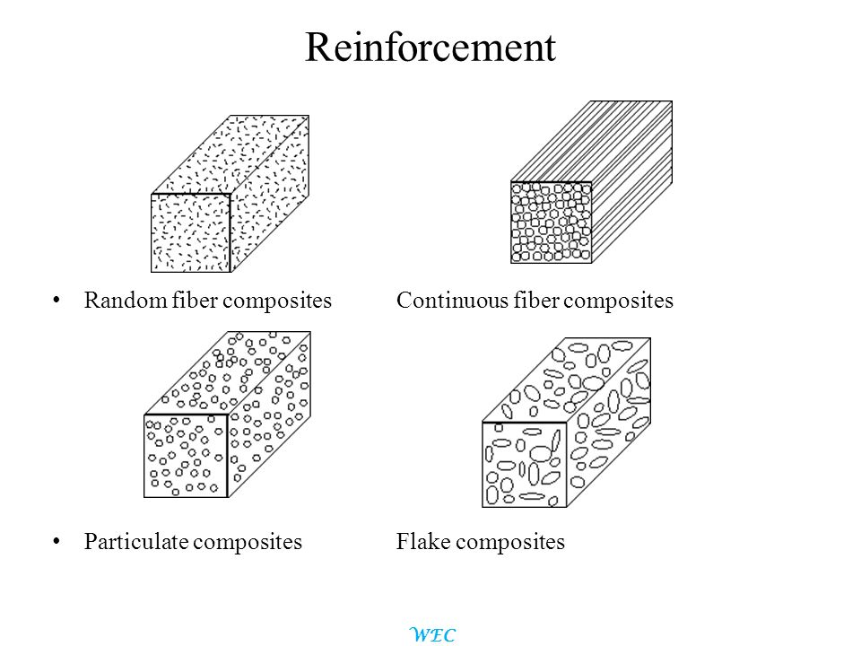

**Fig3.3** Reinforcement intheComposites

**3.3.1 CLASSIFICATION OF REINFORCEMENT**

**Composites Laminar:**

Composites Laminarare found in as many combinations as the number of materials. They can be described as materials comprising of layers of materials bonded together. These may be of several layers of two or more metal materials occurring alternately or in a determined order more than once, and in as many numbers as required for a specific purpose

**Particulate Reinforced Composites (PRC):**

Microstructures of metal and ceramics composites, which show particles of one phase strewn in the other, are known as particle reinforced composites. Square, triangular and round shapes of reinforcement are known, but the dimensions of all their sides are observed to be more or less equal. The size and volume concentrationof the dispersoiddistinguishes it from dispersion hardened materials.

**Fiber Reinforced Composites/Fiber Reinforced Polymer (FRP) Composites:**

Fibers are the important class of reinforcements, as they satisfy the desired conditions and transfer strength to the matrix constituent influencing and enhancing their properties as desired. Glass fibers are the earliest known fibers used to reinforce materials. Ceramic and metal fibers were subsequently found out and put to extensive use, to render composites stiffer more resistant to heat. Fibers fall short of ideal performance due to several factors. The performance of a fiber composite is judged by its length, shape, orientation, and composition of the fibers and the mechanical properties of the matrix. The orientation of the fiber in the matrix is an indication of the strength of the composite and the strength is greatest along the longitudinal directional of fiber. This doesn’t mean the longitudinal fibers can take the same quantum of load irrespective of the direction in which it is applied.

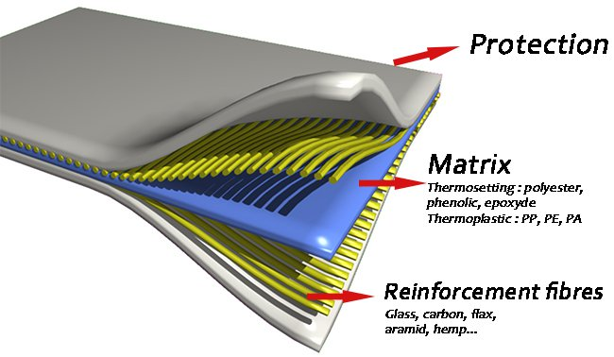

**CHAPTER 4**

**MATERIALS**

**4.1 Carbon Fiber**

The primary element of CFRP is a carbon filament: this is produced from a precursor polymer such as poly acrylonitrile (PAN), rayon, or petroleum pitch. For synthetic polymers such as PAN or rayon, the precursor is first spun into filament yarns, using chemical and mechanical processes to initially align the polymer chains in a way to enhance the final physical properties of the completed carbon fiber. Precursor compositions and mechanical processes used during spinning filament yarns may vary among manufacturers. After drawing or spinning, the polymer filament yarns are then heated to drive off non-carbon atoms (carbonization), producing the final carbon fiber. The carbon fibers filament yarns may be further treated to improve handling qualities, then wound on to bobbins. From the elementary fiber, a bidirectional woven sheet can be created, i.e. a twill with a 2/2 weave. The process by which most CFRPs are made varies, depending on the piece being created, the finish (outside gloss) required, and how many of this particular piece is going to be produced. In addition, the choice of the matrix can have a profound effect on the properties of the finished composite. The carbon fiberized in this paper is as shown in Figure

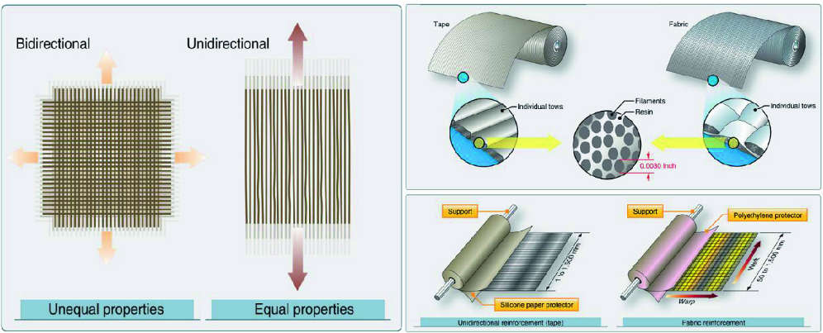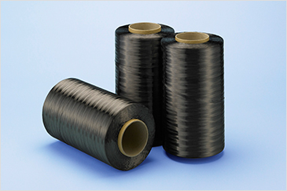

**Fig4.1** Carbon fiber

**4.1.1 Properties of Carbon Fibers**

* Physical strength, specific toughness, light weight.
* Good vibration damping, strength, and toughness.
* High dimensional stability, low coefficient of thermal expansion, and low abrasion.
* Electrical conductivity.
* Biological inertness and x-ray permeability.
* Fatigue resistance, self-lubrication, high damping.
* Electromagnetic properties.
* Chemical inertness, high corrosion resistance.

Table No. 4.1.1

|  |  |
| --- | --- |
| **Material Properties** | **Carbon Fiber** |
| Density (kg/m3) | 1600 |
| Young’s Modulus (Pa) | 70*109 |
| Poisson’s Ratio | 0.1 |
| Bulk Modulus(Pa) | 2.9167*1010 |
| Shear Modulus(Pa) | 3.1818*1010 |
| Ultimate Compressive Strength(Pa) | 1.9*108 |
| Specific Modulus | 43.75 |
| Stiffness (N-m) | 26830 |

**Application Carbon Fiber**

* Aerospace, road and marine transport, sporting goods.
* Missiles, aircraft brakes, aerospace antenna and support structure, large telescopes, optical benches, waveguides for stable high-frequency (GHz) precision measurement frames.
* Audio equipment, loudspeakers for Hi-fi equipment, pickup arms, robot arms.
* Automobile hoods, novel tooling, casings and bases for electronic equipments, EMI and RF shielding, brushes.
* Medical applications in prostheses, surgery and x-ray equipment, implants, and tendon/ligament repair.
* Textile machinery, genera engineering.
* Chemical industry; nuclear field; valves, seals, and pump components in process plants.
* Large generator retaining rings, radiological equipment

**4.2 Glass Fiber**

There are two main types of glass fiber manufacture and two main types of glass fiber product. First, fiber is made either from a direct melt process or a marble remit process. Both start with the raw materials in solid form. The materials are mixed together and melted in a furnace. Then, for the marble process, the molten material is sheared and rolled into marbles which are cooled and packaged. The marbles are taken to the fiber manufacturing facility where they are inserted into a can and re-melted. The molten glass is extruded to the bushing to be formed into a fiber. In the direct melt process, the molten glass in the furnace goes directly to the bushing for formation.

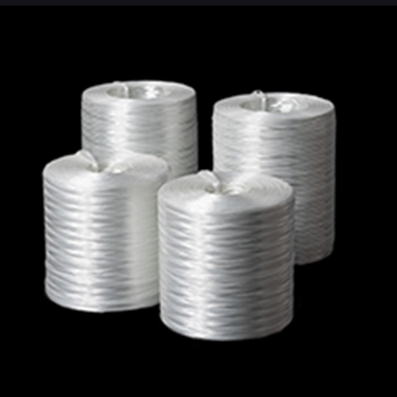 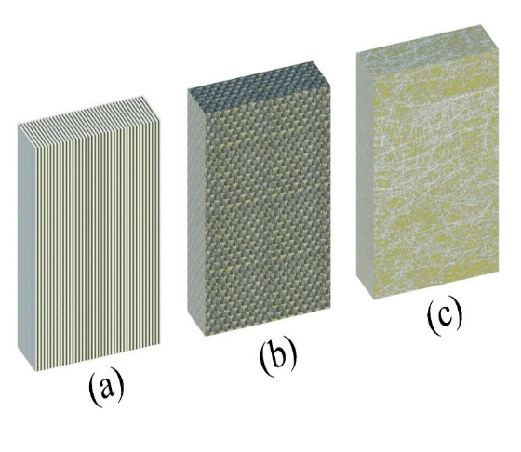

**Fig4.2** Glassfiber

## Table No.4.2.1

|  |  |
| --- | --- |
| **Material Properties** | **Glass Fiber** |
| Density (g/cm3) | 2.56 |
| Young’s Modulus (Pa) | 87*109 |
| Poisson’s Ratio | 0.23 |
| Bulk Modulus(GPa) | 50 |
| Shear Modulus(GPa) | 36 |
| Ultimate Compressive Strength(Psi) | 15,000 to 25,000 |
| Specific Modulus | 43.75 |

## 

## 4.2.1 Properties of glass fiber

* **High tensile strength.** Glass has greater tensile strength than steel wire of the same diameter, at a lower weight.
* **Dimensional stability.** Glass fiber is not sensitive to variations in temperature and hygrometry. It has a low coefficient of linear expansion.
* **High heat resistance.**Glass fabrics retain 50% of room temperature tensile strength at 370°C, 25% at 480°C, a softening point of 845°C and a melting point of 1,135°C.
* **Good thermal conductivity.** Glass fibers are great thermal insulators because of their high ratio of surface area to weight. This property makes it highly useful in the building industry.
* **Great fire resistance.** Since glass fiber is a mineral material, it is naturally incombustible. It does not propagate or support a flame. It does not emit smoke or toxic products when exposed to heat.
* **Good chemical resistance.**Glass fiber is highly resistant to the attack by most chemicals.
* **Outstanding electrical properties.** Glass fiber has a high dielectric strength and low dielectric constant. It is a great electrical insulator even at low thickness.
* **Dielectric permeability.**This property of glass fiber makes it suitable for electromagnetic windows.
* **Compatibility with organic matrices.**Glass fiber can vary in sizes and has the ability to combine with many synthetic resins and certain mineral matrices like cement.
* **Great durability.** Glass fiber is not prone to sunlight, fungi or bacteria.
* **Non-rotting.**Glass fiber does not rot and remains unaffected by the action of rodents and insects.
* **Highly economical.**It is a cost-efficient choice compared to similar materials.

### **Applications of Glass Fiber**

* **Beverage industry**: Fiberglass grating is used in many areas like bottling lines and in brew houses
* **Car washes**: Recently, fiberglass grating is greatly used for rust resistance and to give a contrast color to areas that previously looked forbidden. It brightens the inside of the carwash tunnel making the car look cleaner than it was.
* **Chemical industry**: In this industry, the fiberglass grating is used for anti-slip safety feature of the embedded grit surface and the chemically resistant feature of different resin compounds. The chemicals being used are matched with the resins.
* **Cooling towers**: Since cooling towers are always wet, they have to be protected from rust, corrosion, and other safety issues. Due to the excellent properties of fiberglass, it is used in these towers as screening to keep people and animals away from the danger zones.
* **Food processing**: In the chicken and beef processing plants, fiberglass grating is used for slip resistance and for holding up to blood which is corrosive. Most of the areas of food processing also use fiberglass as other grating materials are not suitable.
* **Fountains and aquariums**: All sizes of fountains and aquariums use fiberglass to support rocks to help in circulation and filtering from under the rocks. In large public fountains, fiberglass grating is used to protect spray headers and lights from getting damaged. This also keeps people from drowning in the fountains.
* **Manufacturing**: The embedded grit surface of fiberglass grating ensures slip resistance in the areas that are wet or in places where hydraulic fluids or oils are present.
* **Metals and mining**: Fiberglass grating is used in electronic refining areas prone to chemical corrosion. Other grating materials cannot be used here.
* **Power generation**: Many areas of the power generation industry like tank farms, scrubbers, and others use fiberglass. The reason for this is the non-conductive property of fiberglass.
* **Pulp and paper industry**: The property of fiberglass which makes it chemical corrosion resistant is useful in pulp and bleach mills. Recently, fiberglass is used in many areas due to its corrosion resistance and anti-slip properties.
* **Automotive industry**: Fiberglass is extensively used in automobile industry. Almost every car has fiberglass components and body kits.
* **Aerospace & Defence**: Fiberglass is used to manufacture parts for both military and civilian aerospace industry including test equipment, ducting, enclosures, and others.

**4.3 Epoxy Resin (Matrix)**

Epoxy resins are more expensive than polyester, but have superior mechanical properties, higher dynamic strength and fatigue resistance. The epoxy resin laminate has low water absorption with high tensile and shear strengths. Epoxy resins are the ultimate choice of the FRP fan blades and are more advantageous in hollow construction. A 250 ml epoxy is taken separately and then mixed with 25 ml of hardener. The hardener is high viscous liquid material, mixed with resin in suitable proportion during the process of preparation of composites which helps in the solidification of the wet, smooth composite. It is used to harden the smooth composite, hence it is called as the hardener. In this project, an EH-758 grade of hardener is used to mix with epoxy resin in 1:10 proportions in the process of manufacturing of composite.



**Fig4.3** Epoxy resin

**4.3.1 Properties of Resins**

* These are transparent or translucent solid or semisolid.
* The specific gravity of Resins is more than water. Therefore, these are heavier than water.
* They generally become soft at heating. On further heating, Resins will be melted.
* Resins generally occur in an amorphous state.
* These are insoluble in water.
* These are soluble in organic compounds like alcohol, volatile oils, and chloral hydrate.
* These compounds are highly enriched with carbon.
* Resins are deprived of nitrogen and oxygen.
* Resins undergo a slow oxidation process in the atmosphere and become dark in color.

Table No.4.3.1

|  |  |
| --- | --- |
| **MATERIAL PROPERTIES** | **EPOXY RESIN** |
| Tensile strength(MPa) | 68-80 |
| Deformation (%) | 5-7 |
| Bending Strength(MPa) | 110-130 |
| Modulus of Elasticity(MPa) | 2.9-3.2 |
| Pressure strength(MPa) | 110-130 |
| Impact Energy(MPa) | 30-50 |

**CHAPTER 5**

**METHODOLOGY**

**Literature**

**Preparation of carbon and glass fibre layers**

**Manufacturing The composites By Hand Layup Method**

**Experimental validation**

**5.1 Carbon Fiber**

In the manufacturing process the raw materials, called precursors, are drawn into long strands of fibers. The fibers are then woven into fabric. They can also be combined with other materials that are filament wound or molded into desired shapes and sizes.

**5.1.1 The manufacturing process goes as follows:**

**Stabilizing**: Chemical alteration to stabilize bonding. Stabilized fibers heated to a very high temperature to form tightly bonded carbon crystals. Before the fibers are carbonized, they need to be chemically altered to convert their linear atomic bonding to a more thermally stable ladder bonding. This is accomplished by heating the fibers in air to about 390-590° F (200-300° C) for 30-120 minutes. This causes the fibers to pick up oxygen molecules from the air and rearrange their atomic bonding pattern. The stabilizing chemical reactions are complex and involve several steps, some of which occur simultaneously.

**Carbonizing**

Once the fibers are stabilized, they are heated to a temperature of about 1,830-5,500° F (1,000-3,000° C) for several minutes in a furnace filled with a gas mixture that does

contain oxygen. The lack of oxygen prevents the fibers from burning in the very high temperatures. The gas pressure inside the furnace is kept higher than the outside air pressure and the points where the fibers enter and exit the furnace are sealed to keep oxygen from entering. As the fibers are heated, they begin to lose their non-carbon atoms, plus a few carbon atoms, in the form of various gases including water vapor, ammonia, carbon monoxide, carbon dioxide, hydrogen, nitrogen, and others. As the non-carbon atoms are expelled, the remaining carbon atoms form tightly bonded carbon crystals that are aligned more or less parallel to the long axis of the fiber. In some processes, two furnaces operating at two different temperatures are used to better control the rate of heating during carbonization.

**Treating the surface**: The surface of fibers is oxidized to improve bonding properties. After carbonizing, the fibers have a surface that does not bond well with the epoxies and other materials used in composite materials. To give the fibers better bonding properties, their surface is slightly oxidized. The addition of oxygen atoms to the surface provides better chemical bonding properties and also etches and roughens the surface for better mechanical bonding properties. Oxidation can be achieved by immersing the fibers in various gases such as air, carbon dioxide, or ozone; or in various.

**Sizing:** Fibers are coated and wound onto bobbins. These are then loaded onto spinning machines that twist the fibers into different size yarns. After the surface treatment, the fibers are coated to protect them from damage during winding or weaving. This process is called sizing. Coating materials are chosen to be compatible with the adhesive used to form composite materials. Typical coating materials include epoxy, polyester, nylon, urethane, and others.

**How is Carbon Fiber Made?**

The raw material used to make carbon fiber is called the precursor. About 90% of the carbon fibers produced are made from polyacrylonitrile (PAN). The remaining 10% are made from rayon or petroleum pitch. All of these materials are organic polymers, characterized by long strings of molecules bound together by carbon atoms. The exact composition of each precursor varies from one company to another and is generally considered a trade secret. During the manufacturing process, a variety of gases and liquids are used. Some of these materials are designed to react with the fiber to achieve a specific effect other materials are designed not to react or to prevent certain reactions with the fiber.

The process for making carbon fibers is part chemical and part mechanical. The precursor is drawn into long strands or fibers and then heated to a very high temperature without allowing it to come in contact with oxygen. Without oxygen, the fiber cannot burn. Instead, the high temperature causes the atoms in the fiber to vibrate violently until most of the non-carbon atoms are expelled.

**5.1.2 HAND LAY TECHNIQUE**

Hand lay-up technique is the oldest method of woven composite manufacturing [30]. The samples are prepared by respecting some steps. First of all, the mold surface is treated by release ant adhesive agent to avoid the sticking of polymer to the surface [31]. Then, a thin plastic sheet is applied at the top and bottom of the mold plate to get a smooth surface of the product. The layers of woven reinforcement are cut to required shapes and placed on the surface of the mold. Thus, as previously mentioned, the resin mixed with other ingredients and infused onto the surface of reinforcement already positioned in the mold using a help brush to uniformly spread it [31]. And then the other mats are placed on the preceding polymer layer and pressured using a roller to remove any trapped air bubbles and the excess of polymer as well. The mold is then closed and pressure is released to obtain a single mat. After curing at room temperature, the mold is opened and the woven composite is removed from the mold surface

Hand lay-up is the simplest and oldest open molding method for fabricating composites. At first, dry fibers in the form of woven, knitted, stitched, or bond fabrics are manually placed in the mold, and a brush is used to apply the resin matrix on the reinforcing material. Subsequently, hand rollers are used to roll the wet composite to ensure an enhanced interaction between the reinforcement and the matrix, to facilitate a uniform resin distribution, and to obtain the required thickness. Finally, the laminates are left to cure under standard atmospheric conditions. Generally, this process is divided into four steps: mold preparation, gel coating, lay-up, and curing. Curing is the process of hardening the fiber-reinforced resin composite without external heat. A pigmented gel coat is first applied to the mold surface to obtain a high-quality product surface. The skills to laminate the reinforcement and matrix, such as resin mixing, laminate resin contents, and the quality of the laminate, are crucial. The laminate is usually achieved with the incorporation of excessive quantities of voids. The lower molecular weights of the hand lay-up resins mean that they have the potential to be more harmful than higher molecular weight products. The lower viscosity of the resins also implies that they have an increased tendency topenetrate clothing. Resins need to be low in viscosity to be workable by hand. This usually compromises their mechanical/thermal properties, due to the need for high diluent/styrene levels. Moreover, the amount of fiber loading relies heavily on the processing method. This is also influenced by the anatomical features of the fibers, which have intra-fiber voids called lumen. The hand lay-up fabrication process is mainly used in marine and aerospace structures

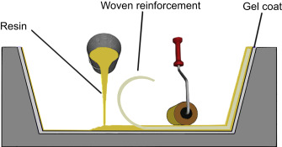

**Fig 5.1.2** Handlayup

**DIMENSIONS OF FRAME (300mm*300mm)**

300 mm

15mm

**5.2 MODEL OF FRAME AND STITCHING**

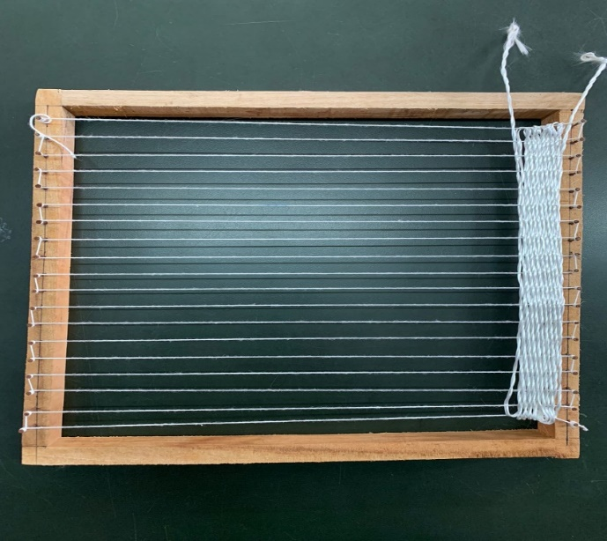 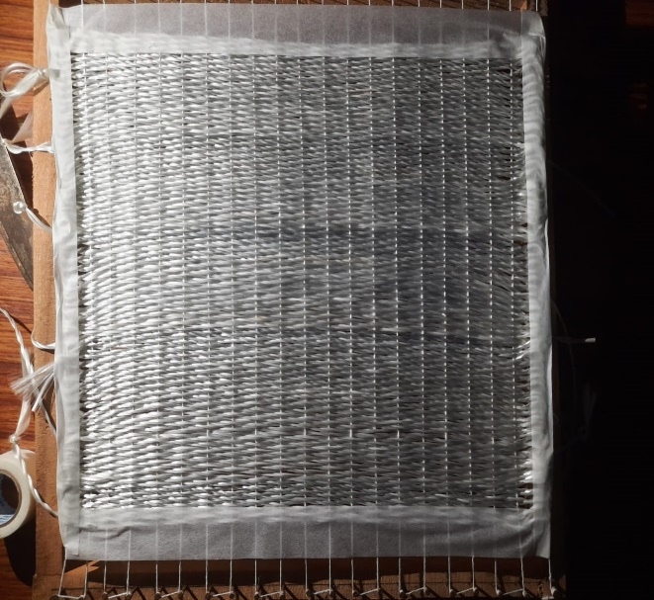

FRAME STICHING

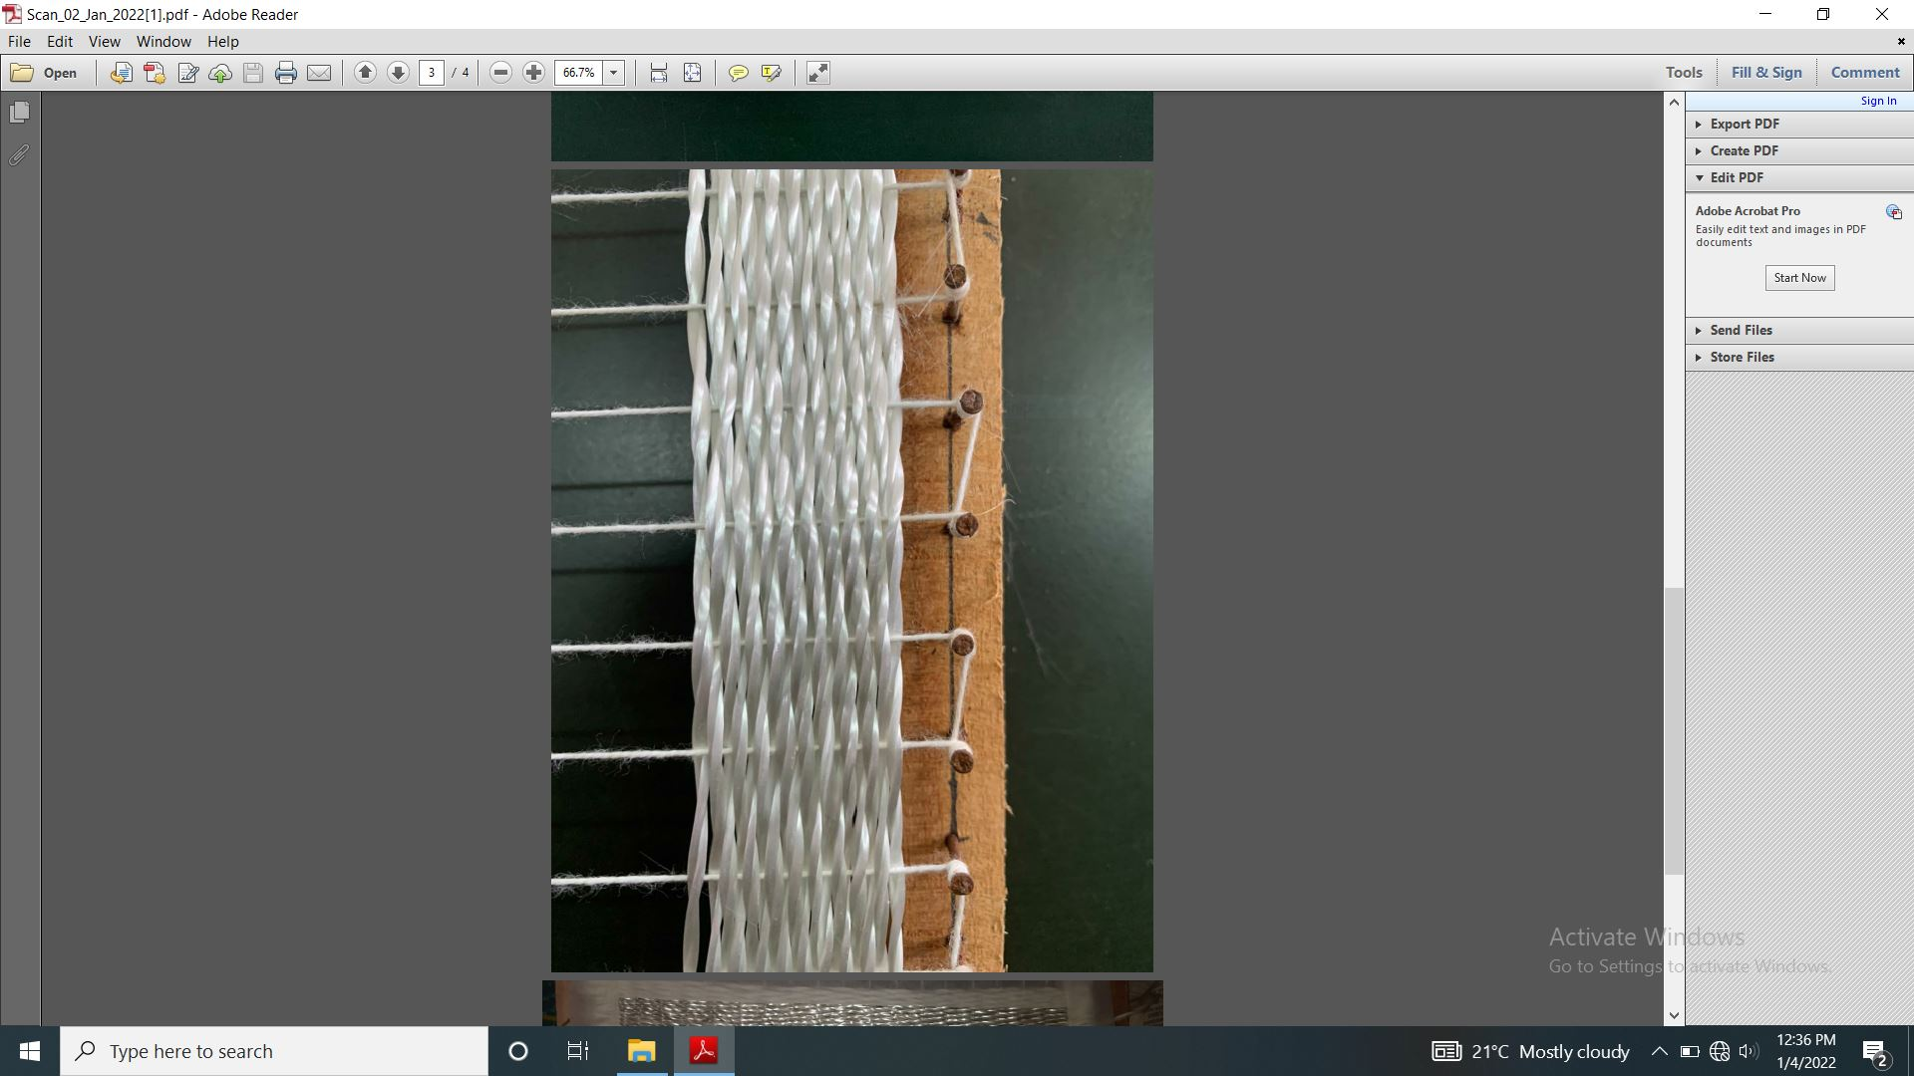

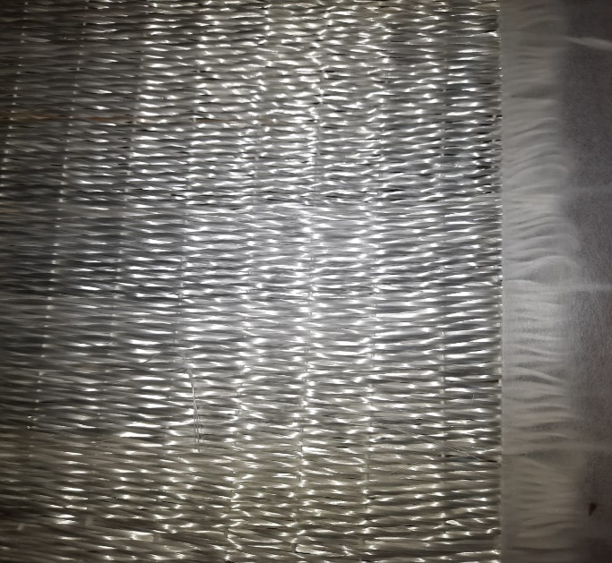

**Fig5.2** Frame & stitching

**CHAPTER 6**

**CONCLUSION**

The aim of this project is to investigate effect of 2 ply Intra woven stitching on mechanical behavior of carbon glass epoxy composite. While doing this project we have studied about composite material reinforcement and matrix. Also we have studied the mechanical properties of Carbon and glass fiber epoxy and method of preparation of laminated sheet.

**CHAPTER 7**

**WORK TO BE CARRIED**

* We are going to prepare interwoven sheets of glass And Carbon fiber
* We are going to manufacture laminated composite of these sheets using epoxy resin.
* And we are going to carry out two fiber test to estimate the tensile strength & strain to failure.

**REFERENCE**

[1] Nathawat POOPAKDEE, Warut THAMMAWICHAI Journal of Metals, Materials and Minerals 31 (1), 2021

[2] MN GuruRaja, AN HariRao Journal of Advances in Material 2 (3), 36-41, 2013

[3] Chensong Dong, Ian J Davies Advanced Composites and Hybrid Materials 1 (3), 530-540, 2018

[4] Qingtao Wang, Weili Wu, Wei Li Polymers 10 (4), 343, 2018

[5] MN GuruRaja, AN HariRao Journal of Minerals and Materials Characterization and Engineering 1 (5), 231-235, 2013

[6]Jagannatha, T.D. and Harish, G. (2015) Influence of Carbon & Glass Fiber Reinforcements on Flexural Strength of Epoxy Matrix Polymer Hybrid Composites. International Journal of Engineering Research and Applications; 5 (4). pp. 109-112. ISSN 2248 - 9622

[7] Hafiz Tauqeer Ali, Roya Akrami, Sakineh Fotouhi, Farzad Pashmforoush, Cristiano Fragassa, Mohammad Fotouhi Facta Universitatis, Series: Mechanical Engineering 18 (1), 069-077, 2020

[8] Qingtao Wang, Weili Wu, Wei Li Polymers 10 (4), 343, 2018

[9] Hasan Ikbal, Qingtao Wang, Ahmed Azzam, Wei Li Fibers and Polymers 17 (9), 1505- 1521, 2016

[10] J Zhang, K Chaisombat, S He, CH Wang Sustainable Automotive Technologies 2012, 69-74, 2012

[11] Jin Zhang, Khunlavit Chaisombat, Shuai He, Chun H Wang Materials & Design (1980-2015) 36, 75-80, 2012

[12]NK Naik, R Ramasimha, HEMENDRA Arya, SV Prabhu, N ShamaRaoComposites Part B: Engineering 32 (7), 565-574, 2001